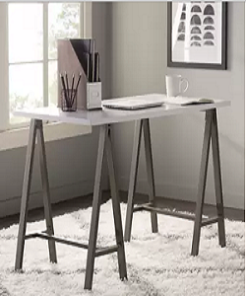

Modern writing desk

$39.21

Availability: In stock

**Description:**

Brown metal rectangular writing desk with 4 metal legs to ensure stability and support. A clear striped glossy top provides a place for any items you want to show off, while boxy sled-style base below sports a sleek metallic finish for an on-tred look.this narrow design is perfect look for living room.Assembly is required.